RECIPE  
Broccoli Beef

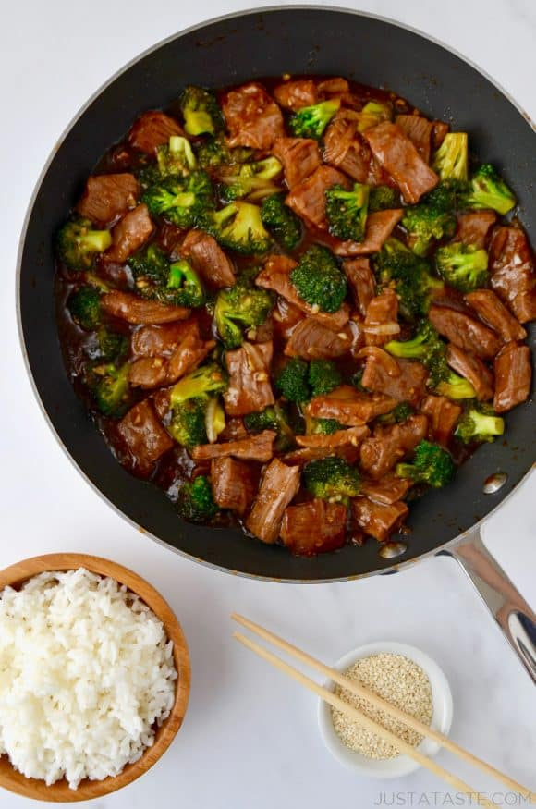

# Ingredients

* 3 tbsp cornstarch
* 1lb beef, cut into 1 inch strips
* ½ cup low sodium soy sauce
* 3 tbsp brown sugar
* 1 tbsp minced garlic
* 2 tsp grated ginger
* 2 tbsp vegetable oil, divided
* 4 cups broccoli florets
* ½ cups sliced onion
* ¾ cup water

# Preparation

1. Add 1 tbsp of the vegetable oil to a large saucepan and fry the beef srips
2. As it is frying, mix together the cornstarch, soy sauce, brown sugar, ginger, and water in a small bowl. Reserve it for later
3. When the beef is done frying, remove it from the pan and add the remaining vegetable oil. Sautee the broccoli and the onion until tender
4. Add back in the beef and pour in the sauce. Cook until thickened and serve over rice.